**Mr.D.Bharath**

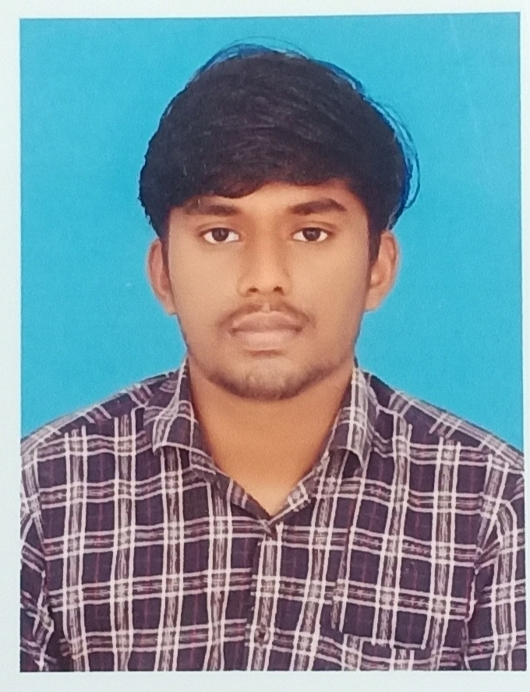

+91-6385201842

sreelathadurai7173@gmail.com

https://github.com/Durai-Bharath

**Objective**

To secure a challenging position in a reputable organization to expand my learnings, knowledge, and skills.

**Education**

**Mepco Schlenk Engineering College, Sivakasi**

B. Tech Artificial Intelligence and Data Science (CGPA-8.53), 2020-2024

**SAV Balakrishna Mat.Hr.Sec.School, Tirunelveli**

HSC (TNBSE) (PERCENTAGE-80), 2020

**St.Ann’s Mat.Hr.Sec.School, Tirunelveli**

SSC (TNBSE) (PERCENTAGE-95.3), 2018

**Projects**

* **Health condition check** using Random Forest algorithm Sep 2022 – Oct 2022
* **Eco-Friendly office** using CISCO packet tracer Sep 2022 – Oct 2022
* **Hall Analytics System** in MongoDB,Node.JS Sep 2022 – Oct 2022
* **Dining Philosopher problem** using Semaphores in JavaMay 2022 - Jun 2022
* **Student Attendance System using face recognition** in python

May 2022 - Jun 2022

* **Movie Recommendation System** based on collaborative filtering(SVD algorithm)

in pythonMay 2022 - Jun 2022

* **GUI** for DBMS project in python(Pyqt5) Nov 2021-Dec 2021
* **Sports Shop Management** in MySQL Nov 2021-Dec 2021
* **Sudoku solver** in c Nov 2021-Dec 2021

**Achievements**

* Won scholarship for securing CGPA above 8.5(RS.15000) 2022
* secured Elite rank in Data Science for Engineers in NPTEL exam 2022
* Secured runner position in zone hockey meet 2018
* won 2nd position in open district hockey meet 2014

**Soft Skills**

* Communication
* Problem Solving
* Analytical Thinking
* Leadership
* Time management

**Technical Skills**

**Languages**: C , C++ , JAVA , R , Python , H TML/CSS , SQL , JavaScript , NoSQL(MongoDB ,

Cassandra ,Neo4j , Hive) , Gawk.

**Frameworks**: Pyspark , sklearn.

**Developer Tools:** Github , VS code , Google colab , Google Cloud Platform , Pycharm , Eclipse,

Sublime , Weka , Orange

**Libraries**: pandas , Numpy , Matplotlib.